Patrick Victorino Miranda
Raduan Oliveira Galli Muarrek
Rodrigo Campos Rodrigues
Pedro de Carvalho Rezende

Hakutaku: Knowledge Management Solution with Artificial Intelligence

SÃO PAULO
2025

Patrick Victorino Miranda
Raduan Oliveira Galli Muarrek
Rodrigo Campos Rodrigues
Pedro de Carvalho Rezende

Hakutaku: Knowledge Management Solution with Artificial Intelligence

Final Course Project submitted to the Institute of Technology and Leadership (INTELI), to obtain a bachelor's degree in Information Systems.
Advisor: Prof. Cesar Almiñana

SÃO PAULO
2025

Cataloging in Publication
Library and Documentation Service
Institute of Technology and Leadership (INTELLI)
Data entered by the author.
(Cataloging record with international cataloging data, according to NBR 14724. The record will be completed later, after approval and before the final version is deposited. The completion of the cataloging record is the responsibility of the institution's library.)



Acknowledgments

We would like to express our sincere gratitude to Vinicios Venancio Lugli, Chief Technology Officer (CTO) of Hakutaku, for his invaluable contributions to the completion of this final course project. His technical expertise and dedicated support were instrumental in shaping the solution, and his commitment significantly enhanced the overall quality and depth of the research and solution presented.
We also extend our sincere thanks to Samuel Veloso, from Maya Capital, our mentor during the entrepreneurship stage, whose fundamental guidance and strategic insights were crucial to the development of the business plan.
We would also like to extend our deepest gratitude to the Institute of Technology and Leadership (INTELI) for providing the stimulating and practical academic environment essential for developing an entrepreneurial project of this nature. A special thank you is reserved for our esteemed advisor, Prof. Cesar Almiñana, whose continuous mentorship, insightful feedback, and dedication were crucial in guiding our research and ensuring the quality and strategic direction of the Hakutaku solution throughout this final course project.

Epigraph
"In an economy where the only certainty is uncertainty, the one sure source of lasting competitive advantage is knowledge."

— Ikujiro Nonaka

Resumo

MIRANDA, Patrick; MUARREK, Raduan; RODRIGUES, Rodrigo; REZENDE, Pedro. Hakutaku. 2025. nº de folhas. TCC (Graduação) – Sistemas de Informação, Instituto de Tecnologia e Liderança, São Paulo, 2025.

A gestão do conhecimento é um desafio crítico para organizações modernas, onde a perda de capital intelectual e a ineficiência na busca por informações geram prejuízos significativos e retrabalho constante. Este trabalho apresenta o Hakutaku, uma solução tecnológica inovadora baseada em Inteligência Artificial Generativa e na arquitetura RAG (Retrieval-Augmented Generation) para capturar, organizar e facilitar o acesso ao conhecimento corporativo de forma centralizada. O objetivo principal foi desenvolver uma plataforma capaz de unificar bases de dados fragmentadas e permitir consultas intuitivas em linguagem natural, democratizando o acesso à informação interna. A metodologia aplicada envolveu uma análise aprofundada de mercado, o dimensionamento do público-alvo (TAM/SAM/SOM), o desenvolvimento de um MVP funcional utilizando Large Language Models (LLMs) e uma estratégia de validação comercial através de landing pages e campanhas de tráfego pago. Os resultados obtidos indicam a viabilidade técnica e mercadológica da solução, demonstrando um potencial concreto para reduzir drasticamente o tempo de onboarding e mitigar a perda de conhecimento tácito. O plano de negócios elaborado projeta a sustentabilidade financeira do empreendimento e um crescimento escalável, posicionando o Hakutaku como uma ferramenta estratégica indispensável para a eficiência operacional das empresas.

Palavras-chave: Gestão do conhecimento; Inteligência artificial; RAG; Eficiência operacional; Chatbot corporativo.

ABSTRACT

MIRANDA, Patrick; MUARREK, Raduan; RODRIGUES, Rodrigo; REZENDE, Pedro. Hakutaku. 2025. nº of pages. Final course project ( Bachelor ) – Information Systems, Institute of Technology and [Leadership , São Paulo, 2025.
Knowledge management is a critical challenge for modern organizations, where the loss of intellectual capital and inefficiency in searching for information generate significant losses and constant rework. This work presents Hakutaku, an innovative technological solution based on Generative Artificial Intelligence and the RAG (Retrieval-Augmented Generation) architecture to capture, organize, and facilitate access to corporate knowledge in a centralized manner. The main objective was to develop a platform capable of unifying fragmented databases and enabling intuitive queries in natural language, democratizing access to internal information. The methodology applied involved an in-depth market analysis, target audience sizing (TAM/SAM/SOM), the development of a functional MVP using Large Language Models (LLMs), and a commercial validation strategy through landing pages and paid traffic campaigns. The obtained results indicate the technical and market feasibility of the solution, demonstrating concrete potential to drastically reduce onboarding time and mitigate the loss of tacit knowledge. The developed business plan projects the financial sustainability of the venture and scalable growth, positioning Hakutaku as an indispensable strategic tool for the operational efficiency of companies.

Keywords: Knowledge management; Artificial intelligence; RAG; Operational efficiency; Corporate chatbot.

Summary

1. Introduction 9
1.1. Context and Motivation 9
1.1.1 Validation and Market Context 9
1.1.2 Validation through Competitions (Hackathons) 9
1.1.3 Validation through Company Feedback 10
1.2 Problem Definition and Value Proposition 10
1.3 Objectives of the Work 12
1.4 Justification and Contributions 12
1.5 Work Structure 12
2. Solution Development 13
2.1 Definition of Market Premises and Hypotheses 13
2.1.4 Customer Segments and Requirements 14
2.2 Market Sizing and Analysis 15
2.3 Competitive Analysis and Differentiators 18
2.3.1 Competitor Analysis 18
2.3.2 Competitive Advantage and Differentiators 19
2.4 Technological Solution 20
2.4.1 Requirements and Specifications 20
2.4.2 Architecture and Technology 20
2.4.3 Development and Implementation (MVP) 21
2.4.4 Testing and Security 21
2.4.4.1 Data Protection and Infrastructure 22
2.4.4.2 Protection Against Data Leakage and Misuse 22
2.4.4.3 Defense Against AI Model Attacks 22
2.4.4.4 Compliance, Governance, and Continuous Monitoring 23
2.5 The Business Plan 23
2.5.1 Market and Competitor Analysis (SWOT) 23
2.5.2 Business Model (BMC) 23
2.5.3 Marketing and Sales Strategy 24
2.5.4 Financial Projection and Feasibility 24
2.5.4.1 Investment Pillars 24
2.5.4.2 Planned Investments 25
2.5.4.3 Structured Investment Plan 27
2.5.4.4 Conclusion 30
2.5.5 Financial Projection – Hakutaku 30
2.5.5.1 Introduction 30
2.5.5.2 Estimated Revenue Without Investment 31
2.5.5.2 Estimated Revenue With Investment 32
2.5.5.2 Projected Cash Flow – Hakutaku 34
2.5.5.2 Conclusion 41
2.6 Validation and Results 42
2.6.1 Validation Methodology 42
2.6.2 Market Validation Results 42
2.6.3 Risks and Mitigation 43
3. Conclusion 43
References 45
Annexes 46

1. Introduction
Knowledge management is characterized as the process of capturing, organizing, sharing, and utilizing knowledge within an organization. There are two types of knowledge: tacit and explicit. Explicit knowledge can be expressed in a formal and systematic language, while tacit knowledge is highly personal and difficult to formalize. An effective knowledge management approach encompasses both types, aiming to make them easily accessible within a company. However, there is often no efficient management in this regard. Frequently, HR departments develop internal management systems or opt to acquire specialized software that, due to its closed nature and outdated design, fails to share knowledge between different departments.

1.1. Context and Motivation
Artificial intelligence can extend across multiple areas, gradually enabling the creation of knowledge management software that meets the needs of various departments within a company. Despite these advantages, senior leadership still faces challenges in implementing this technology effectively.
To validate the existence of this issue, market research, field data collection, and participation in competitions were conducted, which provided significant insights and validations regarding the relevance of the problem.

1.1.1 Validation and Market Context
The significance of effective knowledge management is widely recognized, yet its practical execution remains a challenge for many organizations. A 2024 Notion survey revealed that while 97% of leaders acknowledge the importance of knowledge management, only 44% believe their organizations implement it effectively. This data highlights a substantial gap between the perceived relevance of the topic and its real-world application.

1.1.2 Validation through Competitions (Hackathons)
The concept behind Hakutaku has been consistently validated in competitive environments, reinforcing the solution's acceptance and consistency.
- Stark Bank Hackathon: The initial concept for Hakutaku was proposed during this event, focusing on AI applications in the financial market. Feedback from the internal team, who identified "disorganization within the company" (a common issue in rapidly growing startups), provided clear validation of the problem's relevance, despite not winning the top prize.
- Bemobi Hackathon: Presenting the solution with its current core features and functionalities, Hakutaku secured first place. This victory further solidified the market need for the proposed solution.

1.1.3 Validation through Company Feedback
Direct engagement with companies across different sectors underscores the widespread nature of knowledge management difficulties and how Hakutaku addresses these issues.
- Farmoquímica SA: A trade marketing analyst highlighted the difficulty in accessing information, where employees frequently resort to asking colleagues on Microsoft Teams for assistance. This scenario directly illustrates Hakutaku's potential to streamline knowledge access.
- Vault: The CTO pointed out significant onboarding challenges, where new hires spend unproductive time, causing delays for themselves and other team members. This emphasizes the solution's impact on operational efficiency.
- Mavericks: The CFO brought up succession issues, observed both at their current company and during their tenure at Citi. This feedback stresses the critical problem of losing tacit knowledge when experienced employees depart.
These practical examples and quantitative findings conclusively affirm that knowledge management challenges are globally recognized and actively experienced across diverse organizational settings.

1.2 Problem Definition and Value Proposition
The problem we are addressing is knowledge management, which is characterized by the strategy and practice of managing all the content and data generated by the company in recent years. In practice, this issue requires considerable discipline and organization, involving everything from creating useful information to storing, managing, and controlling access (as detailed in Section 1.1.1).
Consequently, most companies face difficulties, especially in:
- Organizing their documents and knowledge;
- Creating new documents that effectively record data and knowledge;
- Sharing information between departments;
- Unifying knowledge into a single platform;
- Establishing a robust document search system.
These challenges lead to significant problems, such as:
- Operational Inefficiency: Employees may spend hours searching for the same information.
- Succession Issues: Employees who leave take tacit knowledge with them, resulting in the loss of intellectual capital.
- Lengthy Onboarding Processes: New hires require the time of multiple workers to clarify questions that could be answered with proper documentation and organization.
- Data Fragmentation: Extensive searches across multiple platforms are needed to find desired information, which is not only inconvenient but also generates additional costs with platform maintenance.
From a financial perspective, these issues create significant problems for companies. Reduced efficiency means more time is needed to complete a task. Succession and onboarding problems ultimately relate to the same efficiency issue, as new employees need to interrupt the experienced team, occupying the time of both parties. In addition to these financial concerns, effective knowledge management generates less tangible but equally valuable benefits: leveraging the knowledge acquired over the years to enhance daily activities and problem-solving. For example, if a consultancy has already conducted a go-to-market project, the ideal is to review both the macro and micro aspects of the previous project to improve future implementations. This allows the company to continuously learn from the information generated by past experiences.
Value Proposition: Hakutaku delivers an intelligent knowledge management platform that centralizes fragmented corporate data into a single, accessible source of information. By offering a chatbot powered by Generative AI and RAG, the solution provides precise and contextual answers in real-time. It not only automates the updating of knowledge bases and ensures secure cross-departmental sharing but also strategically mitigates the loss of tacit knowledge. By streamlining access to information, Hakutaku significantly reduces onboarding times and operational inefficiency, transforming accumulated knowledge into a lasting competitive advantage.

1.3 Objectives of the Work
- General: Create and validate a computational solution (Hakutaku) utilizing LLM and RAG technologies to solve corporate knowledge management challenges and develop a business plan for its market introduction.
- Specifics:
  - Develop an MVP featuring a chatbot and data ingestion system.
  - Validate the solution through market research and landing page lead generation.
  - Define a robust business model and financial projection.
  - Structure an investment plan to accelerate growth.

1.4 Justification and Contributions
The solution addresses a critical market gap where traditional software fails. From a financial perspective, solving these issues reduces costs associated with wasted time and onboarding delays. Strategically, it allows companies to continuously learn from past experiences. Validations with companies like Farmoquímica SA, Vault, and Mavericks confirmed the urgency of addressing succession problems and information retrieval difficulties.

1.5 Work Structure
The subsequent chapters detail the development of the solution, organized as follows:
- Section 2 (Solution Development): Details the end-to-end creation of the venture.
  - 2.1 Market Premises: Defines foundational hypotheses for problem, solution, and value proposition.
  - 2.2 Market Sizing: Quantifies market potential using TAM, SAM, and SOM analysis.
  - 2.3 Competitive Analysis: Evaluates the landscape against players like Glean and defines local differentiators.
  - 2.4 Technological Solution: Specifies system architecture (RAG/LLM), requirements, and MVP implementation.
  - 2.5 Business Plan: Presents the strategic roadmap, marketing strategies, and financial projections.
  - 2.6 Validation: Describes methodology and results from market research and lead generation campaigns.
- Section 3 (Conclusion): Synthesizes project findings, confirms objective achievement, and proposes future steps.

2. Solution Development

2.1 Definition of Market Premises and Hypotheses
This section details the strategic analysis and definition of the market assumptions that guided the project, establishing the foundation for the business model.
2.1.1 Problem Hypothesis
We identified that companies with fragmented knowledge bases face significant operational inefficiency and loss of intellectual capital. The central hypothesis is that these organizations suffer from specific pain points—such as lengthy onboarding processes, succession issues when employees leave, and wasted time searching for information—and are actively seeking and willing to pay for a solution that centralizes this data. The lack of effective management leads to measurable financial losses and prevents companies from learning from past experiences.
2.1.2 Solution Hypothesis
We posit that a platform utilizing Large Language Models (LLM) combined with Retrieval-Augmented Generation (RAG) is the most effective way to address this problem. Unlike traditional folder-based organization, this technological approach allows users to query unified internal documents using natural language. The hypothesis validates that an AI-driven chatbot, capable of retrieving context from various file formats (.docx, .pdf) and external integrations (Google Drive), provides the necessary precision and speed to solve the "disorganization" pain point without requiring the client to manually restructure their entire database.
2.1.3 Value Hypothesis
We assume that an accessible pricing model is the key driver for adoption in the Brazilian market. While global competitors target enterprise clients with high ticket prices, our hypothesis is that medium-sized companies (SMBs) require a similar technology but with lower barriers to entry. Specifically, we project that a price point below R$ 100.00 per user and a minimum requirement of 20 users (75% lower than the market standard of 80) will be sufficient to validate the commercial viability of the product and capture the underserved mid-market segment.

2.1.4 Customer Segments and Requirements
Understanding the customer profile is essential for Hakutaku's positioning. We identified two main categories:
- Ideal Customer Profile (ICP): Large companies with hundreds of employees, possessing a consolidated knowledge base and financial capacity for higher tickets. These organizations benefit most from scale but require a mature product.
- Entry-Level Focus: Medium-sized companies experiencing rapid growth. These organizations typically suffer from "disorganization" and process bottlenecks but lack the budget for enterprise legacy solutions.
Minimum Viability Requirements: Based on benchmarking with global competitors like Glean, we defined optimized requirements to make Hakutaku accessible:
- Data Structure: The client must have a minimal base of digital documents (structured or unstructured) to feed the RAG system.
- User Base: Unlike competitors requiring minimums of 80 users, Hakutaku is viable for teams as small as 20 users.
- Financial Accessibility: The solution is designed for companies that cannot afford high-end dollarized contracts, positioning Hakutaku as the cost-effective local alternative.

2.2 Market Sizing and Analysis
To determine the addressable market size for our product, we adopted a three-step segmentation process: TAM (Total Addressable Market), SAM (Serviceable Available Market), and SOM (Serviceable Obtainable Market). Each of these indicators represents a distinct portion of the market, considering different criteria of accessibility and penetration capacity. TAM represents the total available market, meaning the maximum potential value that could be reached if all companies and consumers in the target market used the product or service. SAM, in turn, reflects the accessible market based on more specific characteristics of companies or consumers who can effectively use the solution. Finally, SOM represents the portion of the market that can be effectively captured by the company, considering factors such as competition and execution capacity.
The following sections present the calculation logic and the sources used to determine the available market size for Hakutaku in each of these segments.
2.2.1 TAM (Total Addressable Market): R$ 86.8 Billion.
Before presenting the methodology used for the calculations and definition of our TAM, it is important to clarify which data were considered. We aimed to adopt a precise and reliable bottom-up strategy. To achieve this, we used metrics based on the number of companies with more than 50 employees, multiplied by our average ticket per employee and the average number of employees per company to determine the market size.
First, it is essential to explain how we arrived at the threshold of 50 employees. This value was defined based on our strategic objectives, particularly regarding the competitive advantage, which set a target of 20 employees per company, as described in section 3.6. To ensure, in a conservative manner, that the company has at least 20 employees with the potential to use the platform (i.e., those who work directly with computers and data handling), we opted to adopt the criterion of 50 employees. To obtain this information, we used data from Econodata, which, in March 2025, indicated the existence of 401,720 companies with more than 50 employees in Brazil.
To determine the average number of employees per company, we used data from the 2014 IBGE Trade Survey. Although this survey is outdated in terms of the total number of companies, it provides a general overview of the distribution of employees per company, allowing us to calculate the average number of employees per company. Based on the median of each company size category, we obtained the following results:
- 8,464 companies with 75 employees
- 4,292 companies with 175 employees
- 1,126 companies with 375 employees
- 851 companies with 1,000 employees
From this data, we calculated a weighted average of 180 employees per company.
By multiplying the total number of companies with more than 50 employees (401,720) by the average number of employees per company (180) and the projected average ticket mentioned in section 3.6 (R$ 100 per month, totaling R$ 1,200 per year), we obtain the following result:
401,720 x 180 x 1,200 = 86,771,520,000
That is, a TAM (Total Addressable Market) of approximately R$ 86.8 billion, calculated using the bottom-up approach, as illustrated below:
[Figure 1 - TAM Hakutaku]
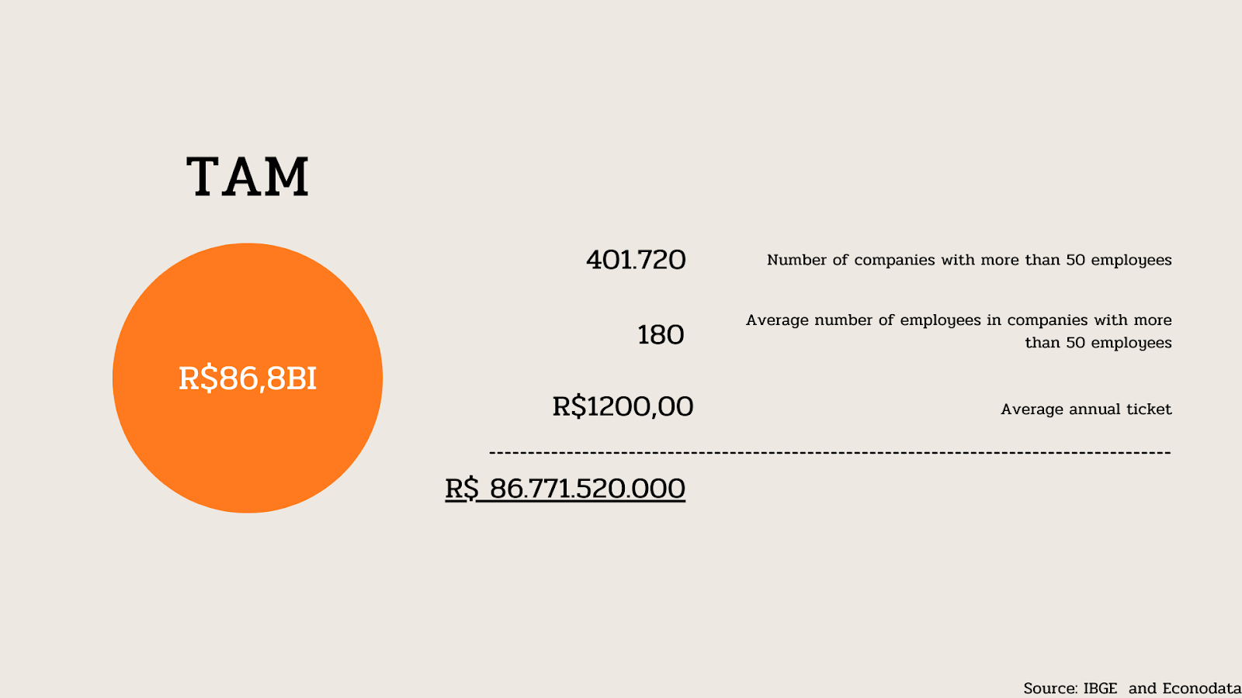
Source: Prepared by the authors, 2025.
2.2.2 SAM (Serviceable Available Market): R$ 71.2 Billion | SOM (Serviceable Obtainable Market): R$ 7.3 Billion.
After calculating the market that represents our TAM, we carried out market segmentations to define the SAM (Serviceable Available Market) and the SOM (Serviceable Obtainable Market).
Initially, we defined our SAM as companies that use computers with internet access. According to the 2010 IBGE Census, 82.2% of companies with more than 10 employees use computers with internet for their daily activities. Based on this, we calculated the following segmentation:
86,771,520,000 x 0.82 = 71,152,646,400
Thus, our SAM is R$ 71.2 billion.
Regarding SOM, we applied a segmentation based on the city of São Paulo, which, according to IBGE data from 2019, accounted for 10.3% of the country's GDP. This allowed us to perform the following calculation:
71,152,646,400 x 0.103 = 7,328,722,579
Thus, the SOM was estimated at R$ 7.3 billion, as illustrated below, along with the SAM and SOM.
[Figure 2 - TAM, SAM, SOM Hakutaku]
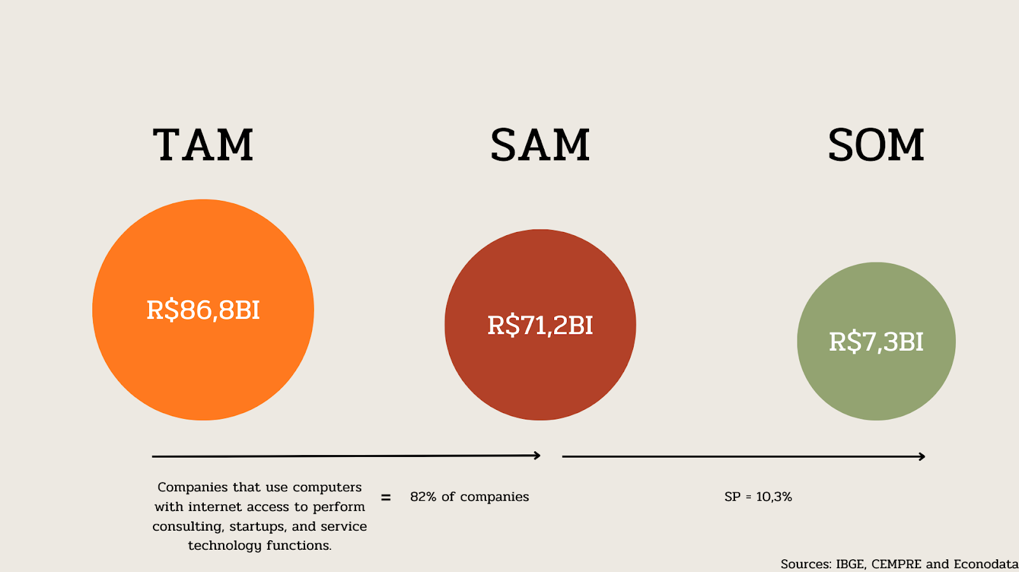
Source: Prepared by the authors, 2025.
After segmentation, we obtained the following results:
- TAM = R$ 86.8 billion
- SAM = R$ 71.2 billion
- SOM = R$ 7.3 billion

2.3 Competitive Analysis and Differentiators

2.3.1 Competitor Analysis
To understand the requirements for adopting this type of solution, we gathered information from Glean, a global reference platform in AI for knowledge management. To achieve this, we presented ourselves as potential customers to understand what would be required for a company to become one of their clients.
After multiple email exchanges and a video conference, we obtained the following insights:
- The company must have a well-established documentation base before implementing the solution.
- The minimum package offered was for 80 users.
- The annual cost of the basic package was $80,000.
Based on the strategies and requirements of our main global competitor, we identified key metrics and factors that need to be considered when identifying potential customers, particularly because Glean’s solution is the closest to the one we plan to develop.

2.3.2 Competitive Advantage and Differentiators
Therefore, to ensure the planned value delivery for our knowledge management project while creating a competitive advantage over the competitor analyzed in our research, we decided to focus on making our product more accessible to medium-sized companies and more suited to the Brazilian market.
To effectively deliver this competitive advantage, we have set the following goals for product development:
- 75% reduction in the number of required users, decreasing from 80 to 20.
- 75% reduction in the average ticket price per user, designing an architecture that allows for a cost below R$100.00 per user.
- Development of a robust system for knowledge maintenance and creation, enabling work with knowledge bases that are not fully organized.
- Localization of the platform into Portuguese, ensuring greater accessibility for the Brazilian audience.
By designing a more accessible and optimized platform from the outset, we aim to provide a solution that reduces the need for large teams, minimizes the required pre-existing documentation, and offers a more competitive cost. This way, we seek to serve medium and small businesses that have not yet had access to such technology, making it more viable, especially for the Brazilian market.

2.4 Technological Solution
This section presents the technological architecture, requirements, and implementation of the Hakutaku solution.

2.4.1 Requirements and Specifications
Key requirements gathered for the MVP include:
- Chatbot: Initiate conversation, send messages to LLM, save history, and respond within 30 seconds (95% of requests).
- Data Ingestion: Consume data from vector databases, process .docx/.xlsx files, and integrate with Google Drive.
- Administrator: Manage users, roles, and view usage metrics.
To efficiently address the knowledge management challenges described in the project's introduction, the Hakutaku solution requires advanced technologies capable of unifying, processing, and intuitively interacting with company data. The primary technical approach selected for this project involves integrating Large Language Models (LLM) with Retrieval-Augmented Generation (RAG), providing an intelligent chatbot interface for internal knowledge queries.

2.4.2 Architecture and Technology
The solution utilizes a RAG (Retrieval-Augmented Generation) architecture to integrate LLMs with corporate data.
- LLM: Gemini (via LangChain) for natural language processing.
- RAG: Integration of retrieval-based models to fetch relevant information from the knowledge base before generating responses.
- Database: PostgreSQL (Supabase) for relational data and Upstash for vector database (embeddings).
- Infrastructure: AWS (hosting), Docker/Kubernetes (containerization), and GitHub Actions (CI/CD).
- Frontend: React and TypeScript for a responsive interface.
[Figure 3: Technology and Structure - Hakutaku]
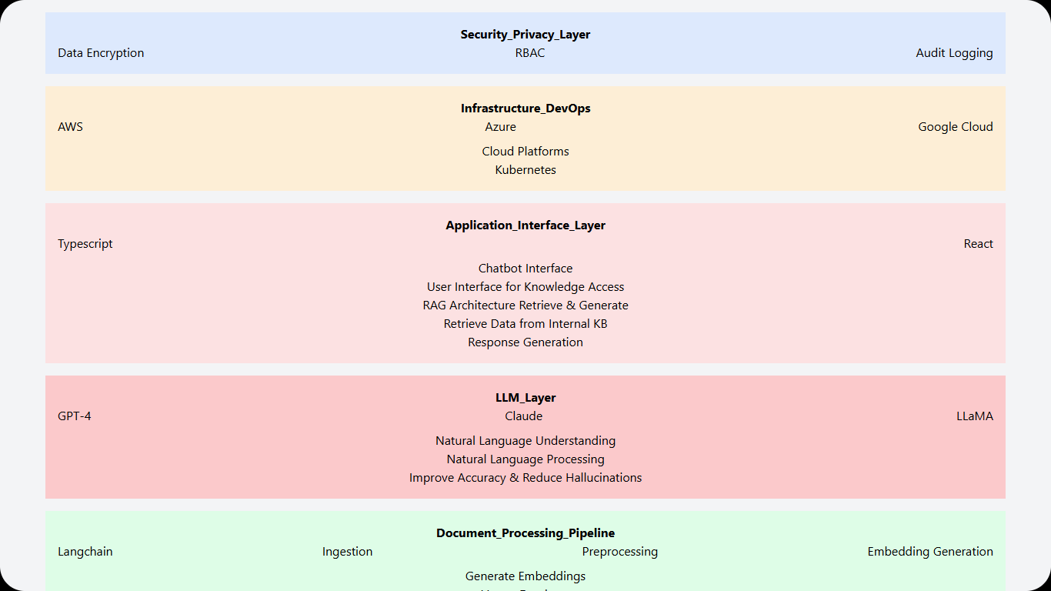
Source: Prepared by the authors, 2025.

2.4.3 Development and Implementation (MVP)
The development was divided into modules:
- Chatbot Interface: Developed using React, featuring a home screen with suggested prompts and a conversation screen similar to market standards (e.g., ChatGPT).
- RAG System: Implemented using Upstash. The system vectorizes user documents and retrieves them as context for the LLM.
- Integrations: Development of "Connectors" (e.g., Google Drive via SSO) to automatically feed the knowledge base.

2.4.4 Testing and Security
The sensitive nature of corporate internal data requires rigorous privacy and security measures to ensure the confidentiality, integrity, and availability of information. The Hakutaku solution adopts multiple layers of protection, combining encryption, access control, auditing, and AI-specific strategies to mitigate risks such as data leakage, misuse, and attacks on language models.

2.4.4.1 Data Protection and Infrastructure
- Data Encryption: Implementation of end-to-end encryption for data in transit and at rest, using standards such as AES-256 for storage and TLS 1.3 for secure communication.
- Role-Based Access Control (RBAC): Ensures that users access only the data necessary for their roles, minimizing exposure to sensitive information.
- Identity and Access Management (IAM): Implements multi-factor authentication (MFA) and strict permission controls for APIs and services.
- Audit and Log Monitoring: Detailed logging of system interactions to detect suspicious activities, ensure regulatory compliance, and maintain governance.
- Redundancy and Secure Backup: Automated backup mechanisms and secure storage for recovery in case of incidents.

2.4.4.2 Protection Against Data Leakage and Misuse
- Input/Output Filtering: Implementing techniques to sanitize queries and model responses, preventing exposure of sensitive information.
- Data Anonymization and Obfuscation: Reducing the risk of storing confidential information within the model using techniques like differential privacy.
- AI Response Validation: Using Retrieval-Augmented Generation (RAG) to ensure that answers are based solely on authorized sources.
- Confidence Thresholds and Human Review: Defining thresholds to block low-confidence responses and allow manual supervision when necessary.

2.4.4.3 Defense Against AI Model Attacks
- Prompt Injection Protection: Implementing filters to prevent command manipulations that could lead to unauthorized responses.
- Model Extraction Protection: Limiting repetitive queries and applying obfuscation techniques to hinder reverse engineering of the model.
- AI Response Monitoring: Keeping detailed logs of all interactions for forensic analysis and continuous security improvements.

2.4.4.4 Compliance, Governance, and Continuous Monitoring
- Regulatory Compliance (LGPD, GDPR): Implementing policies to ensure compliance with data protection laws, including the right to be forgotten and explicit consent.
- Explainability and Transparency: Maintaining detailed documentation of model decisions for audits and to enhance system trust.
- AI Security Testing (Red Teaming): Simulating attacks to identify vulnerabilities and strengthen defenses.
- AI Incident Response: Establishing clear procedures to handle failures or accidental data exposures.
By integrating advanced AI technologies with robust security and privacy frameworks, Hakutaku ensures a reliable and effective knowledge management solution, enhancing both corporate data integrity and user experience.

2.5 The Business Plan

2.5.1 Market and Competitor Analysis (SWOT)
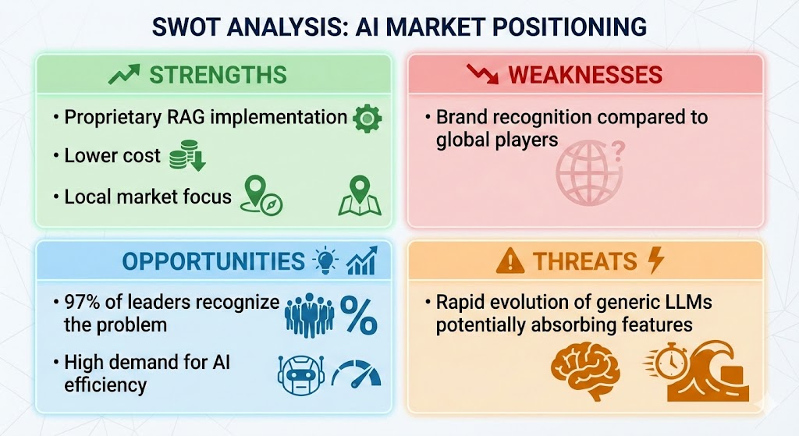

2.5.2 Business Model (BMC)
- Revenue Model: SaaS subscription model (approx. R$ 99.90 per user/month).
- Value Proposition: Centralized knowledge, time saving, and tacit knowledge retention.

2.5.3 Marketing and Sales Strategy
- Go-to-Market: Use of landing pages with paid traffic (Meta Ads) to capture leads.
- Sales Funnel: Attraction via ads -> Landing Page (Logical/Emotional appeal) -> Lead Capture Form -> Direct Sales.
- Investments: Budget allocation for paid traffic (R$ 2,625/month initially) and participation in events.

2.5.4 Financial Projection and Feasibility
Hakutaku’s investment plan was designed with the purpose of identifying which resources and investments are necessary to boost the company in the best possible way at this initial stage, ensuring that Hakutaku takes full advantage of the market timing regarding generative AI.
More than just securing the financial sustainability of operations, this investment plan aims to structure the resources required to accelerate platform development, expand brand visibility, and strengthen our commercial structure. The focus is on creating the right conditions for Hakutaku to establish itself in the Brazilian market.

2.5.4.1 Investment Pillars
Hakutaku’s investment plan was structured around three main pillars that reflect the company’s priorities at this stage: product acceleration, go-to-market strategy, and competitive barrier development. These pillars served as the foundation for the resource allocation plan, ensuring that every investment effectively contributes to the company’s growth and consolidation.
[Figure 28: Hakutaku’s Investment Pillars]
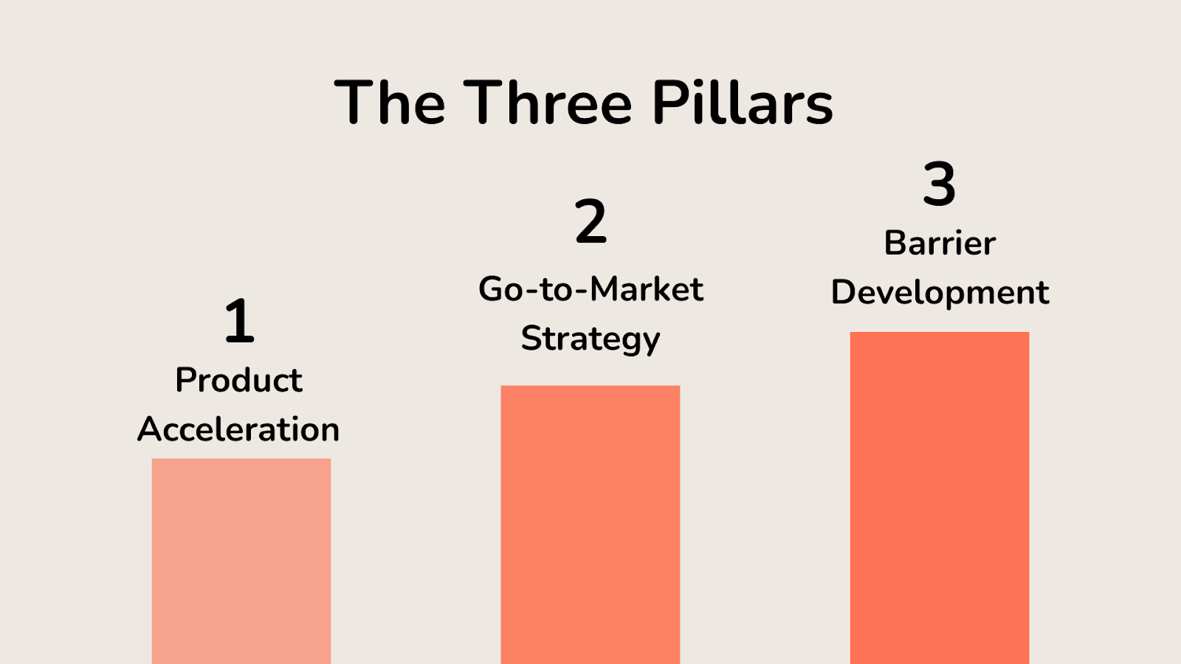
Source: Prepared by the authors, 2025.
The first pillar, product acceleration, focuses on reducing development time, enabling the solution to reach clients faster. This accelerates product growth in the market and allows us to serve as many clients as possible.
The second pillar, go-to-market strategy, aims to structure Hakutaku’s market entry, enabling the company to acquire its first clients. This pillar seeks to accelerate revenue generation, validate our client acquisition channel and ICP, and ensure the product is ready to scale consistently.
The third pillar, Barrier development, is centered on creating technological differentiators that make the solution more competitive and increase entry barriers for new competitors, especially international competitors. The goal is to build proprietary assets that strengthen Hakutaku’s position in the market and reduce the risk of being replaced by competing alternatives.
Together, these three pillars form the foundation of Hakutaku’s investment plan, guiding decisions on how resources from a potential investment will be allocated.

2.5.4.2 Planned Investments
The investments were planned to cover Hakutaku’s first year of operations after funding, structured to address both existing operational needs and to enable product and customer base growth. Below is an overview of the planned investments and their objectives:
- Budget for participation and hosting of events: Validate events as a client acquisition channel, both by joining third-party initiatives and by creating our own.
- Budget for testing and experimentation of services: Enable the use of tools and applications that continuously improve the product.
- Cloud processing: Ensure an adequate environment for solution development on AWS.
- AI credits: Enable testing of different AI models and functionalities.
- Accounting: Maintain financial and fiscal compliance.
- Corporate workspace: Provide digital work infrastructure and licenses for the team.
- Company domain: Ensure digital identity and official brand presence.
- Founders’ compensation (pró-labore): Allow the founders to dedicate themselves fully to the product, reducing hiring costs.
- Legal services for fundraising: Structure the legal aspects of the investment round.
- Amendments to the articles of association: Adjust the company to legal requirements of fundraising.
- Legal reserve: Prepare the company for future legal and contractual demands.
- Freelancers for design and UX: Improve platform design, visual identity, and user experience.
- Junior Back-end developer: Support the development of integrations and functionalities.
- Front-end developer: Enhance platform design and usability.
- Equipment (laptops and accessories): Ensure proper working conditions for new hires.
- Employee for paid traffic and commercial activities: Expand the customer base and test acquisition channels.
- Lead capture and monitoring tool: Support commercial initiatives and sales funnel creation.
- Paid traffic budget: Expand visibility and client acquisition capacity.
Taken together, these investments enable Hakutaku to advance consistently, balancing product development, operational structuring, and strengthening its presence in the Brazilian market.

2.5.4.3 Structured Investment Plan
After defining the strategic pillars and identifying the main resource destinations, a structured investment plan was developed for Hakutaku’s first year. This planning clearly organizes how each amount will be allocated, allowing greater financial control and making it easier to prioritize the most relevant investments for the company’s growth.

Allocation of Value in the First Year | Average Monthly Value (R$) | Timing | Total Value in Year 1 (R$) | Objective
Budget for participation and hosting of events | R$ 1.000,00 | from month 1 | R$ 11.000,00 | The objective of this investment is to validate events as a customer acquisition channel for Hakutaku from the beginning, both by participating in third-party events and by creating our own. (channel creation)
Budget for testing and experimentation of services | R$ 500,00 | from month 1 | R$ 6.000,00 | The objective of this investment is to enable testing of tools and services that can continuously improve the quality of our product. (product improvement)
Cloud processing | R$ 400,00 | from month 1 | R$ 4.800,00 | The objective of this investment, although we have credits, is to ensure we have an adequate environment to develop the solution on AWS. (product improvement)
AI credits | R$ 450,00 | from month 1 | R$ 5.400,00 | The objective of this investment is to enable testing of different AIs for product development and improvement, both for new features and for replacing existing models with better ones. (product improvement)
Accounting | R$ 189,00 | from month 1 | R$ 2.268,00 | Recurring monthly expense to maintain our accounting. (fixed costs)
Corporate workspace | R$ 700,00 | from month 1 | R$ 8.400,00 | Recurring expense to maintain our Workspace and later hire more licenses for new employees of the company. (fixed costs)
Company domain | R$ 0,00 | from month 1 | R$ 800,00 | Annual expense to maintain the company’s domain registrations. (fixed costs)
Founders’ compensation (pró-labore) | R$ 7.500,00 | from month 1 | R$ 90.000,00 | Compensation so that the founding partners, all technical, can remain 100% dedicated to the product, which generates significant savings in hiring development staff. (product improvement)
Legal services for fundraising | R$ 0,00 | month 1 | R$ 10.000,00 | Payment for the legal process of conducting the investment round. (legal)
Amendments to the articles of association | R$ 0,00 | month 1 | R$ 1.300,00 | Payment for amendments to the articles of association resulting from the investment round. (legal)
Legal reserve | R$ 0,00 | month 1 | R$ 15.000,00 | Investment in a reserve for future legal matters the company may face, such as lawsuits and the creation of contracts for the product. (legal)
Freelancers for design and UX | R$ 1.500,00 | months 2–3 | R$ 3.000,00 | Investment in freelancers to improve visual identity, UX, and platform design, mainly while a specialized developer has not yet been hired. (product improvement)
Junior Back-end developer | R$ 4.500,00 | from month 2 | R$ 54.000,00 | Investment mainly focused on building and improving the product, expanding our range of integrations and the number of potential clients we can serve. (product improvement)
Front-end developer | R$ 4.500,00 | from month 4 | R$ 40.500,00 | Investment focused on improving the design and user experience of the platform. With this investment, the main goal is to increase customer retention on the platform. (churn reduction)
Equipment (laptops and accessories) | R$ 0,00 | month 4 | R$ 12.000,00 | Investment in company equipment, mainly focused on providing working tools for new employees. (asset investment)
Employee for paid traffic and commercial activities | R$ 4.000,00 | from month 4 | R$ 36.000,00 | Investment in hiring an employee mainly focused on client acquisition and channel testing. (customer base expansion and new channel testing)
Lead capture and monitoring tool | R$ 2.000,00 | from month 4 | R$ 16.000,00 | Investment in software for lead management and monitoring, enabling the work of the new hire. (customer base expansion)
Paid traffic budget | R$ 2.625,00 | from month 4 | R$ 21.000,00 | Investment in paid traffic to support commercial investments made at this stage and expand our client acquisition capacity. (customer base expansion)
TOTAL |  |  | R$ 337.468,00

2.5.4.4 Conclusion
The investment plan was built to guide Hakutaku’s growth, uniting operational needs, product evolution, and customer base expansion. With this organization, the company will be able to allocate received resources more effectively. Thus, beyond sustaining short-term operations, the planned investments create the necessary conditions for Hakutaku to strengthen itself and move toward consolidation in the Brazilian market.

2.5.5 Financial Projection – Hakutaku

2.5.5.1 Introduction
The financial projection of Hakutaku was developed with the purpose of estimating the company’s economic performance over the next year, allowing the anticipation of future capital needs, as well as providing metrics to evaluate our performance and strategies in the future. It also serves as a basis for decision-making.
In this sense, the financial projection seeks to translate Hakutaku’s investments into practical results, creating a roadmap on how the company can sustain its growth, achieve profitability, and strengthen its market position.

2.5.5.2 Estimated Revenue Without Investment
To better understand the impact of an investment round on Hakutaku’s results, a performance simulation was conducted over one year without the raising of new funds. This analysis highlights more clearly how financial contributions can directly impact our revenue. All calculations were made considering an estimated sales price of R$99.90 per subscription.

Month | Clients | Average number of licenses | Total licenses | MRR | Costs | Taxes | Net
1 | 3 | 10 | 30 | R$ 2.997,00 | R$ 599,40 | R$ 299,70 | R$ 2.097,90
2 | 3 | 10 | 30 | R$ 2.997,00 | R$ 599,40 | R$ 299,70 | R$ 2.097,90
3 | 4 | 10 | 40 | R$ 3.996,00 | R$ 799,20 | R$ 399,60 | R$ 2.797,20
4 | 4 | 10 | 40 | R$ 3.996,00 | R$ 799,20 | R$ 399,60 | R$ 2.797,20
5 | 5 | 10 | 50 | R$ 4.995,00 | R$ 999,00 | R$ 499,50 | R$ 3.496,50
6 | 5 | 15 | 75 | R$ 7.492,50 | R$ 1.498,50 | R$ 749,25 | R$ 5.244,75
7 | 6 | 15 | 90 | R$ 8.991,00 | R$ 1.798,20 | R$ 899,10 | R$ 6.293,70
8 | 7 | 15 | 105 | R$ 10.489,50 | R$ 2.097,90 | R$ 1.048,95 | R$ 7.342,65
9 | 8 | 15 | 120 | R$ 11.988,00 | R$ 2.397,60 | R$ 1.198,80 | R$ 8.391,60
10 | 8 | 15 | 120 | R$ 11.988,00 | R$ 2.397,60 | R$ 1.198,80 | R$ 8.391,60
11 | 9 | 25 | 225 | R$ 22.477,50 | R$ 4.495,50 | R$ 2.247,75 | R$ 15.734,25
12 | 10 | 25 | 250 | R$ 24.975,00 | R$ 4.995,00 | R$ 2.497,50 | R$ 17.482,50

As can be observed, even without investments the company would have the potential to achieve relevant results, such as an MRR of R$25,000 and a user base of 250. However, it is important to emphasize that these numbers represent only a conservative scenario and could be significantly increased with the inflow of investments.

2.5.5.2 Estimated Revenue With Investment
To evaluate the effect of raising investments on Hakutaku’s results, a simulation was conducted considering the planned capital injection. This analysis demonstrates how investments can accelerate the company’s growth and significantly expand its revenue. All calculations were based on the estimated sales price of R$99.90 per subscription.

Month | Clients | Average number of licenses | Total licenses | MRR | Costs | Taxes | Net
1 | 2 | 10 | 20 | R$ 1.998,00 | R$ 399,60 | R$ 199,80 | R$ 1.398,60
2 | 3 | 10 | 30 | R$ 2.997,00 | R$ 599,40 | R$ 299,70 | R$ 2.097,90
3 | 4 | 10 | 40 | R$ 3.996,00 | R$ 799,20 | R$ 399,60 | R$ 2.797,20
4 | 5 | 15 | 75 | R$ 7.492,50 | R$ 1.498,50 | R$ 749,25 | R$ 5.244,75
5 | 6 | 15 | 90 | R$ 8.991,00 | R$ 1.798,20 | R$ 899,10 | R$ 6.293,70
6 | 8 | 15 | 120 | R$ 11.988,00 | R$ 2.397,60 | R$ 1.198,80 | R$ 8.391,60
7 | 9 | 15 | 135 | R$ 13.486,50 | R$ 2.697,30 | R$ 1.348,65 | R$ 9.440,55
8 | 12 | 15 | 180 | R$ 17.982,00 | R$ 3.596,40 | R$ 1.798,20 | R$ 12.587,40
9 | 14 | 20 | 280 | R$ 27.972,00 | R$ 5.594,40 | R$ 2.797,20 | R$ 19.580,40
10 | 17 | 25 | 425 | R$ 42.457,50 | R$ 8.491,50 | R$ 4.245,75 | R$ 29.720,25
11 | 17 | 30 | 510 | R$ 50.949,00 | R$ 10.189,80 | R$ 5.094,90 | R$ 35.664,30
12 | 18 | 35 | 630 | R$ 62.937,00 | R$ 12.587,40 | R$ 6.293,70 | R$ 44.055,90

[Figure 29 – Without Funding vs. With Funding]
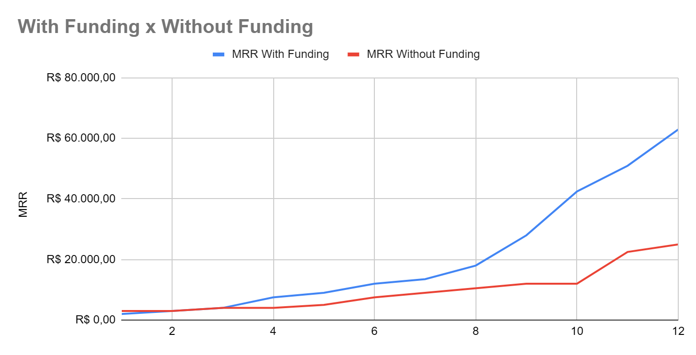
Source: Prepared by the authors, 2025.
As shown, the capital injection enables results that are significantly higher than in the conservative no-investment scenario, projecting an MRR of R$63,000 and a base of 630 users at the end of the period. This would represent a 250% faster growth rate for the company. These results reflect the direct impact of investments made possible by the raised resources, including marketing, hiring employees, and improving the platform. Thus, raising capital proves essential to ensuring accelerated growth and quickly consolidating Hakutaku’s position in the market, making the most of the timing provided by the AI industry.

2.5.5.2 Projected Cash Flow – Hakutaku
Hakutaku’s projected cash flow was designed to anticipate the inflow and outflow of financial resources throughout the coming year, allowing for an evaluation of the company’s financial health and ensuring that planned investments and growth remain sustainable. Unlike the revenue projection, which only considers expected inflows, the cash flow also accounts for all expenses, including operating costs, investments, salaries, and infrastructure.
Developing this projection makes it possible to identify periods in which there may be greater need for working capital, as well as indicating the moments when the company will have more financial slack to make new investments. Thus, it consolidates itself as a strategic tool to ensure that Hakutaku maintains sufficient resources to operate while sustaining an accelerated growth pace with new funding whenever necessary.
Table – Projected Cash Flow (Months 1–6)

 | 1 | 2 | 3 | 4 | 5 | 6
Monthly Fee | R$ 1.998,00 | R$ 2.997,00 | R$ 3.996,00 | R$ 7.492,50 | R$ 8.991,00 | R$ 11.988,00
Integrations | R$ 0,00 | R$ 0,00 | R$ 0,00 | R$ 0,00 | R$ 1.500,00 | R$ 1.500,00
Received | R$ 1.998,00 | R$ 2.997,00 | R$ 3.996,00 | R$ 7.492,50 | R$ 10.491,00 | R$ 13.488,00
INVESTMENT CASH FLOW
Equipment (notebooks and accessories) | R$ 0,00 | R$ 0,00 | R$ 0,00 | R$ 12.000,00 | R$ 0,00 | R$ 0,00
Frontend Developer for design and visual identity on the platform | R$ 0,00 | R$ 0,00 | R$ 0,00 | R$ 4.500,00 | R$ 4.500,00 | R$ 4.500,00
Monthly expenses with freelancers for design and visual identity on the platform | R$ 0,00 | R$ 1.500,00 | R$ 1.500,00 | R$ 0,00 | R$ 0,00 | R$ 0,00
Junior Backend Developer to develop integrations and frontend | R$ 0,00 | R$ 0,00 | R$ 0,00 | R$ 6.000,00 | R$ 6.000,00 | R$ 6.000,00
Employee for paid traffic and business relations | R$ 0,00 | R$ 0,00 | R$ 0,00 | R$ 4.000,00 | R$ 4.000,00 | R$ 4.000,00
Tool for lead capture and monitoring | R$ 0,00 | R$ 0,00 | R$ 0,00 | R$ 1.200,00 | R$ 1.200,00 | R$ 1.200,00
Budget for paid traffic | R$ 0,00 | R$ 0,00 | R$ 0,00 | R$ 1.800,00 | R$ 1.800,00 | R$ 1.800,00
Budget for participation and organization of events | R$ 0,00 | R$ 1.000,00 | R$ 1.000,00 | R$ 1.000,00 | R$ 1.000,00 | R$ 1.000,00
Budget to test and experiment with services and applications that may improve the product | R$ 500,00 | R$ 500,00 | R$ 500,00 | R$ 500,00 | R$ 500,00 | R$ 500,00
Cloud processing expenses for development | R$ 200,00 | R$ 200,00 | R$ 200,00 | R$ 200,00 | R$ 500,00 | R$ 500,00
AI credits expenses for development purposes | R$ 300,00 | R$ 300,00 | R$ 300,00 | R$ 500,00 | R$ 500,00 | R$ 500,00
(=) TOTAL INVESTMENT | R$ 1.000,00 | R$ 3.500,00 | R$ 3.500,00 | R$ 31.700,00 | R$ 20.000,00 | R$ 20.000,00
EXPENSES (OPERATIONAL ACTIVITIES)
Accounting | R$ 189,00 | R$ 189,00 | R$ 189,00 | R$ 189,00 | R$ 189,00 | R$ 189,00
Legal expenses for fundraising | R$ 10.000,00 | R$ 0,00 | R$ 0,00 | R$ 0,00 | R$ 0,00 | R$ 0,00
Changes in articles of incorporation | R$ 1.300,00 | R$ 0,00 | R$ 0,00 | R$ 0,00 | R$ 0,00 | R$ 0,00
Expenses with company workspace (Google Workspace) | R$ 400,00 | R$ 400,00 | R$ 400,00 | R$ 800,00 | R$ 800,00 | R$ 800,00
Company domain expenses | R$ 800,00 | R$ 0,00 | R$ 0,00 | R$ 0,00 | R$ 0,00 | R$ 0,00
Reserve creation for legal matters | R$ 15.000,00 | R$ 0,00 | R$ 0,00 | R$ 0,00 | R$ 0,00 | R$ 0,00
Partners’ compensation (2,500 x 3) | R$ 7.500,00 | R$ 7.500,00 | R$ 7.500,00 | R$ 7.500,00 | R$ 7.500,00 | R$ 7.500,00
(=) TOTAL EXPENSES | R$ 35.189,00 | R$ 8.089,00 | R$ 8.089,00 | R$ 8.489,00 | R$ 8.489,00 | R$ 8.489,00
CASH FLOW - COSTS FOR PRODUCT OPERATION
Taxes (product service provision) | R$ 299,70 | R$ 299,70 | R$ 399,60 | R$ 599,40 | R$ 749,25 | R$ 899,10
Product operating cost | R$ 599,40 | R$ 599,40 | R$ 799,20 | R$ 1.198,80 | R$ 1.498,50 | R$ 1.798,20
(=) TOTAL OPERATIONAL COSTS | R$ 899,10 | R$ 899,10 | R$ 1.198,80 | R$ 1.798,20 | R$ 2.247,75 | R$ 2.697,30
Total expenses | R$ 37.088,10 | R$ 12.488,10 | R$ 12.787,80 | R$ 41.987,20 | R$ 30.736,75 | R$ 31.186,30
Funding contribution | R$ 250.000,00 | R$ 0,00 | R$ 0,00 | R$ 0,00 | R$ 0,00 | R$ 0,00
Monthly variation | -R$ 35.090,10 | -R$ 9.491,10 | -R$ 8.791,80 | -R$ 34.494,70 | -R$ 20.245,75 | -R$ 17.698,30
Cash | R$ 214.909,90 | R$ 205.418,80 | R$ 196.627,00 | R$ 162.132,30 | R$ 141.886,55 | R$ 124.188,25

Table – Projected Cash Flow (Months 7–12)

 | 7 | 8 | 9 | 10 | 11 | 12
Monthly Fee | R$ 14.985,00 | R$ 17.982,00 | R$ 27.972,00 | R$ 39.960,00 | R$ 50.949,00 | R$ 62.937,00
Integrations | R$ 1.500,00 | R$ 1.500,00 | R$ 5.000,00 | R$ 5.000,00 | R$ 5.000,00 | R$ 5.000,00
Received | R$ 16.485,00 | R$ 19.482,00 | R$ 32.972,00 | R$ 44.960,00 | R$ 55.949,00 | R$ 67.937,00
INVESTMENT CASH FLOW
Equipment (notebooks and accessories) | R$ 0,00 | R$ 0,00 | R$ 0,00 | R$ 0,00 | R$ 0,00 | R$ 0,00
Frontend Developer for design and visual identity on the platform | R$ 4.500,00 | R$ 4.500,00 | R$ 4.500,00 | R$ 4.500,00 | R$ 4.500,00 | R$ 4.500,00
Monthly expenses with freelancers for design and visual identity on the platform | R$ 0,00 | R$ 0,00 | R$ 0,00 | R$ 0,00 | R$ 0,00 | R$ 0,00
Junior Backend Developer to develop integrations and frontend | R$ 6.000,00 | R$ 6.000,00 | R$ 6.000,00 | R$ 6.000,00 | R$ 6.000,00 | R$ 6.000,00
Employee for paid traffic and business relations | R$ 4.000,00 | R$ 4.000,00 | R$ 4.000,00 | R$ 4.000,00 | R$ 4.000,00 | R$ 4.000,00
Tool for lead capture and monitoring | R$ 1.200,00 | R$ 1.200,00 | R$ 2.500,00 | R$ 2.500,00 | R$ 2.500,00 | R$ 2.500,00
Budget for paid traffic | R$ 1.800,00 | R$ 1.800,00 | R$ 3.000,00 | R$ 3.000,00 | R$ 3.000,00 | R$ 3.000,00
Budget for participation and organization of events | R$ 1.000,00 | R$ 1.000,00 | R$ 1.000,00 | R$ 1.000,00 | R$ 1.000,00 | R$ 1.000,00
Budget to test and experiment with services and applications that may improve the product | R$ 500,00 | R$ 500,00 | R$ 500,00 | R$ 500,00 | R$ 500,00 | R$ 500,00
Cloud processing expenses for development | R$ 500,00 | R$ 500,00 | R$ 500,00 | R$ 500,00 | R$ 500,00 | R$ 500,00
AI credits expenses for development purposes | R$ 500,00 | R$ 500,00 | R$ 500,00 | R$ 500,00 | R$ 500,00 | R$ 500,00
(=) TOTAL INVESTMENT | R$ 20.000,00 | R$ 20.000,00 | R$ 22.500,00 | R$ 22.500,00 | R$ 22.500,00 | R$ 22.500,00
EXPENSES (OPERATIONAL ACTIVITIES)
Accounting | R$ 189,00 | R$ 189,00 | R$ 189,00 | R$ 189,00 | R$ 189,00 | R$ 189,00
Legal expenses for fundraising | R$ 0,00 | R$ 0,00 | R$ 0,00 | R$ 0,00 | R$ 0,00 | R$ 0,00
Changes in articles of incorporation | R$ 0,00 | R$ 0,00 | R$ 0,00 | R$ 0,00 | R$ 0,00 | R$ 0,00
Expenses with company workspace (Google Workspace) | R$ 800,00 | R$ 800,00 | R$ 800,00 | R$ 800,00 | R$ 800,00 | R$ 800,00
Company domain expenses | R$ 0,00 | R$ 0,00 | R$ 0,00 | R$ 0,00 | R$ 0,00 | R$ 0,00
Reserve creation for legal matters | R$ 0,00 | R$ 0,00 | R$ 0,00 | R$ 0,00 | R$ 0,00 | R$ 0,00
Partners’ compensation (2,500 x 3) | R$ 7.500,00 | R$ 7.500,00 | R$ 7.500,00 | R$ 7.500,00 | R$ 7.500,00 | R$ 7.500,00
(=) TOTAL EXPENSES | R$ 8.489,00 | R$ 8.489,00 | R$ 8.489,00 | R$ 8.489,00 | R$ 8.489,00 | R$ 8.489,00
CASH FLOW - COSTS FOR PRODUCT OPERATION
Taxes (product service provision) | R$ 1.048,95 | R$ 1.198,80 | R$ 1.998,00 | R$ 2.597,40 | R$ 4.195,80 | R$ 5.594,40
Product operating cost | R$ 2.097,90 | R$ 2.397,60 | R$ 3.996,00 | R$ 5.194,80 | R$ 8.391,60 | R$ 11.188,80
(=) TOTAL OPERATIONAL COSTS | R$ 3.146,85 | R$ 3.596,40 | R$ 5.994,00 | R$ 7.792,20 | R$ 12.587,40 | R$ 16.783,20
Total expenses | R$ 31.635,85 | R$ 32.085,40 | R$ 36.983,00 | R$ 38.781,20 | R$ 43.576,40 | R$ 47.772,20
Funding contribution | R$ 0,00 | R$ 0,00 | R$ 0,00 | R$ 0,00 | R$ 0,00 | R$ 0,00
Monthly variation | -R$ 15.150,85 | -R$ 12.603,40 | -R$ 4.011,00 | R$ 6.178,80 | R$ 12.372,60 | R$ 20.164,80
Cash | R$ 109.037,40 | R$ 96.434,00 | R$ 92.423,00 | R$ 98.601,80 | R$ 110.974,40 | R$ 131.139,20

Based on the projections, Hakutaku’s cash flow shows that, even with negative variations during the first months due to initial investments in infrastructure, marketing, and hiring, as well as the product maturation period, the company tends to gradually reduce this impact and achieve positive results throughout the year after the investment. It is possible that the company will reach break-even by the end of the analyzed period. This behavior reinforces the financial feasibility of the project and highlights that the raised resources will be essential not only to sustain operations in the short term but also to enable investments that will consolidate the company in the long run.

2.5.5.2 Conclusion
Hakutaku’s financial projection highlights the company’s growth potential and reinforces the importance of raising investments to accelerate this process. While the conservative revenue scenario demonstrates viability even without new resources, the funding scenario reveals significantly faster growth. Furthermore, the projected cash flow confirms that, with an investment round, despite the initial challenges arising from infrastructure and expansion costs, the company tends to reach break-even within the analyzed period.
Therefore, the financial analysis demonstrates that Hakutaku is prepared to strategically utilize the raised resources, ensuring operational sustainability in the short term and consolidating its market position in the long term.

2.6 Validation and Results

2.6.1 Validation Methodology
Validation was conducted through:
- Market Research: Surveys with leaders (Notion data) and direct interviews with companies (Farmoquímica, Vault, Mavericks).
- Competitions: Validation of the concept in Hackathons (Stark Bank and Bemobi - 1st place).
- Lead Generation: Development of a Landing Page aimed at conversion, driven by Meta Ads campaigns.

2.6.2 Market Validation Results
- Qualitative: Confirmed pains regarding "disorganization" and "succession issues" in interviewed companies.
- Quantitative (Campaign):
  - Investment: R$ 454.83.
  - Reach: 12,822 people.
  - Leads Captured: 12 form submissions (Cost per Lead approx. R$ 37.90).
  - Conclusion: Public interest validated, though conversion to paid clients is the next step in the funnel.

2.6.3 Risks and Mitigation
- Risk: Data hallucination by AI.
  - Mitigation: Strict RAG implementation with source citation.
- Risk: Data leakage.
  - Mitigation: Enterprise-grade encryption and isolation of client data.

3. Conclusion
This Final Course Project successfully achieved its general objective: to create and validate Hakutaku, a computational solution utilizing Large Language Models (LLM) and Retrieval-Augmented Generation (RAG) technologies to fundamentally address corporate knowledge management challenges, coupled with a robust business plan for its market introduction.
Analysis of Development and Results:
- Technological Solution: The core development was a functional Minimum Viable Product (MVP) featuring an AI-driven chatbot and a data ingestion system. The chosen RAG architecture was technically validated as the most effective approach for unifying fragmented corporate databases, allowing users to query internal documents in natural language with precision and speed.
- Problem Resolution: The solution directly addresses critical pain points in modern organizations, including the significant loss of tacit knowledge due to employee succession, operational inefficiency caused by extensive information searches, and lengthy, costly onboarding processes. By centralizing data and automating knowledge retrieval, Hakutaku demonstrated a concrete potential to mitigate these issues.
- Market and Financial Feasibility: The comprehensive market analysis (TAM/SAM/SOM) and competitive benchmarking confirmed the market viability. A key competitive advantage was developed through a highly accessible pricing model (below R$100.00 per user) and a low minimum user requirement (20 users, a 75% reduction from the global competitor standard), strategically positioning Hakutaku to capture the underserved medium-sized business (SMB) segment in the Brazilian market.
- Validation: The solution's concept was validated both through success in competitive environments (Bemobi Hackathon victory) and direct, positive feedback from companies across various sectors (Farmoquímica SA, Vault, Mavericks), affirming the urgency and relevance of the problem being solved.
In synthesis, the project not only validated the technical feasibility of integrating Generative AI with private data via RAG but also confirmed the financial sustainability and high scalability potential of the venture. Hakutaku is positioned as an indispensable strategic tool for enhancing operational efficiency, transforming accumulated knowledge into a lasting competitive advantage.

References
- DIAS, Mateus. How to build a High-Converting Landing Page - From SCRATCH. [Video]. YouTube, 2025. Available at: https://www.youtube.com/watch?v=oqqNTda2Fhc. Accessed on: Nov. 6, 2025.
- ECONODATA. List of Companies with more than 50 employees in Brazil. Available at: https://www.econodata.com.br/empresas/todo-brasil/mais-de-50-funcionarios. Accessed on: Mar. 26, 2025.
- GLEAN. Work assistant & knowledge management platform. Available at: https://www.glean.com/. Accessed on: Fev. 20, 2025.
- HAKUTAKU TEAM. Transform your Company with AI - Hakutaku. [Online Form]. Available at: https://hakutaku.ai/form. Accessed on: Nov. 6, 2025.
- IBGE. News Agency. City of São Paulo accounts for 10.3% of the country's GDP in 2019. Available at: https://agenciadenoticias.ibge.gov.br/agencia-sala-de-imprensa/2013-agencia-de-noticias/releases/32596-cidade-de-sao-paulo-concentra-10-3-do-pib-do-pais-em-2019. Accessed on: Abr. 20, 2025.
- IBGE. Brazil in Synthesis: trade: number of companies, by occupied personnel categories. Available at: https://brasilemsintese.ibge.gov.br/comercio/numero-de-empresas-por-faixas-de-pessoal-ocupado.html. Accessed on: [Access Date].
- NOTION. Episode 6: Supercharging company knowledge with AI. [Webinar]. Available at: https://info.notion.so/webinar/webinars-amer/notions---episode-6-the-future-of-organisational-knowledge. Accessed on: Mar. 1, 2025.
- POPADIUK, Silvio; SANTOS, Antonio Edson Monteiro dos. Tacit, Explicit and Cultural Knowledge in Demand Planning. JISTEM Journal of Information Systems and Technology Management, São Paulo, v. 7, n. 1, p. 207–226, Apr. 2010.

Annexes

- [1] https://github.com/Inteli-College/2025-1A-T02-G70-PUBLICO/blob/main/Documents/Module%204/Hakutaku%20Business%20plan.pdf
- [2] https://github.com/Inteli-College/2025-1A-T02-G70-PUBLICO/blob/main/Documents/Module%204/Plano%20de%20Projetos%20Hakutaku%20-%20Trilha%20Empreendedorismo%20(Vers%C3%A3o%20Final).pdf https://github.com/Inteli-College/2025-1A-T02-G70-PUBLICO/blob/main/Documents/Module%204/Hakutaku%20Business%20plan.pdf
- [3] https://github.com/Inteli-College/2025-1A-T02-G70-PUBLICO/blob/main/Documents/Module%204/Plano%20de%20Projetos%20Hakutaku%20-%20Trilha%20Empreendedorismo%20(Vers%C3%A3o%20Final).pdf

